

Dynamic, empowered learners who thrive and lead in
their communities: locally, nationally and globally

BOTTISHAM VILLAGE COLLEGE

anti-bullying policy

this policy was  Approved: | summer 2025
this policy will be reviewed: | summer 2027
member of staff with responsibility for review: | deputy principal

Bullying of any kind is unacceptable at Bottisham Village College. We are committed to providing a safe and positive learning environment for all students and staff, in accordance with the Equality Act 2010. This policy sets out our approach to preventing and addressing bullying, drawing on the research of Christina Salmivalli (1996) on the dynamics of peer networks in bullying.
Our definition of bullying:
The repetitive, intentional hurting of one person or group by another person or group, where the relationship involves an imbalance of power.

Repetitive: Refers to behaviour that is ongoing and repeated over time, rather than a one-time occurrence.
Hurtful: Behaviour that causes emotional, physical, or psychological harm to another person.
Intentional: Refers to behaviour that is purposeful and deliberate, rather than accidental or unintentional.
Power imbalance: A power imbalance exists when one person or group has more social, physical, or emotional power or influence than another person or group.
All forms of joking/banter can be deemed “meant” if they make others feel upset, uncomfortable, or unsafe or if they create an imbalance of power.
Bullying can be categorised as follows:

 | Verbal | Indirect | Physical
Definition | The repeated negative use of speech, sign language or verbal gestures to  intentionally harm (hurt) others. | Repeated negative actions, which are neither verbal nor physical to intentionally hurt others. | Repeated negative use of body contact to intentionally hurt others.
Example | Swearing, offensive language, and discriminatory language. | Isolating someone from a group, damaging/taking somebody’s property, physical intimidation or spreading rumours  about someone | Punching, kicking, spitting at someone.

Cyberbullying is:
- flaming/trolling: using extreme and offensive language/insults. The aim of flaming is to cause reactions and people often get enjoyment from the target’s distress.

- catfishing: creating fake profiles on social media network sites, apps and online; - outing exposing: coaxing someone into revealing secrets and forwarding it to others – usually involving screenshots.
- cyberstalking: repeating messages that include threats of harm, harassment, intimidation or engaging in other online activities that make a person afraid for his or her safety.
- exclusion: intentionally leaving someone out of a group such as group messages, online apps, gaming sites and other online engagement.
- online sexual harassment: sending unwanted images or messages of sexual context (their own or others. This could include trying to persuade someone into returning images of themselves and/or doing something they are not comfortable with.
- denigration: sharing information about another person that is false or damaging. Sharing photos of someone for people to make fun of, spreading false rumours and gossip.

The Law
Within the Equality Act 2010, there are nine protected characteristics: age, disability, gender reassignment, marriage and civil partnership, pregnancy and maternity, race, religion or belief, sex, and sexual orientation. Students are explicitly taught about protected characteristics and what they are in the PSHE curriculum. This is returned to every year from 7-11. They are also taught the importance of respecting differences and celebrating diversity features throughout the Personal Development curriculum, including in PSHE and assemblies.
Hate Crime
Our policy recognizes that hate crimes, including bullying, can occur towards individuals based on protected characteristics such as disability, gender reassignment, sexual orientation, race, religion, or belief. We have a statutory requirement to report any incidents of hate crime bullying to the local authority and the police as part of our duty of care. To address this issue, we involve outside agencies, as necessary, to educate students, families, and staff about the consequences of hate crime and the laws protecting the protected characteristics. We take appropriate and immediate action to address and prevent hate crime bullying and create a safe and inclusive environment for all students, regardless of their protected characteristics. We encourage students, staff and parents to report any incidents of hate crime bullying and ensure they have a clear understanding of the process and support they will receive. Furthermore, we continuously monitor and review our policies and procedures to ensure that they are effective in preventing and addressing hate crime and bullying.

What is the difference between bullying and harassment?
Bullying and harassment are similar in that they both involve actions that hurt or harm another person physically or emotionally, and an imbalance of power between the target and the individual demonstrating negative behaviour. However, the main difference between the two is that bullying is defined as repeated that is intended to

cause harm. Whilst harassment is a one-time or repeated behaviour that is based on protected characteristic such as race, religion, gender, sexual orientation, disability, etc. In other words, when the bullying behaviour is motivated by prejudice or discrimination against a protected characteristic, it is considered harassment. It's important to note that Harassment doesn't need to be a repeated behaviour, it can happen in just one instance.

What do we do as a school community

Prevent bullying by:
- Create a safe and inclusive environment where all students feel respected and valued.
- Regularly reinforce the importance of tolerance and celebration of diversity within our college ethos and British values. Bottisham Village College will reinforce this through our curriculum and assemblies.
- Encourage positive behaviour by treating all students with respect and building their confidence.
- Develop student leadership opportunities such as Anti-Bullying ambassadors to promote a positive culture and help prevent bullying.
- Incorporate education about bullying and its consequences into the PSHE curriculum to raise awareness and promote understanding.
- Display school-wide posters that highlight the effects of bullying and the importance of respect and kindness towards one another.
- Provide training for staff to recognize and respond effectively to instances of bullying.
- Identify and support the needs of our most vulnerable students to help them manage relationships and intervene early if problems arise.

Support targets of bullying by:
- telling someone when you know there is bullying taking place;
- providing a place of calm;
- ensuring that students know when and where they can find our Anti-bullying Ambassadors if they wish to speak to a peer;
- giving students access to a mechanism to report concerns in school and this being signposted through safeguarding updates, posters and in tutor time;
- having information readily available online for students
- ensuring follow-up conversations and regular “check-in” dates are put in the diary to ensure the well-being of the target is fully supported and no recurrence is missed.
- ensuring that Pastoral Staff issues follow-up letters or emails to the families of targets.

When someone is being bullied, other students can help by:
If you witness bullying happening in your school, here are some steps you can take:

- Don’t be a bystander. Although sometimes it is difficult to get involved, we know that peers can have a significant impact on stopping bullying from occurring. Within the group dynamic, consider what actions you could take, to defend the target, if you feel confident and safe to do so.
- Report the incident to a trusted adult, such as your form tutor, teacher, or support member of staff. Provide them with as much information as possible, including the names of the individuals involved and any details about the incident. Look at the definition of bullying. Is what you are reporting bullying behaviour?
- If you feel uncomfortable reporting the incident to an adult, you can use the our support@bottishamvc.org email address.
- Be a supportive friend to the victim of bullying. Let them know that they are not alone and that you care about them.
- Speak up if you hear someone else making hurtful or harmful comments. Bullying is not acceptable and it is important to be an advocate for kindness and respect.
- If you are unsure of what to do, reach out to your form tutor, or our Anti- Bullying Ambassadors for guidance and support.
- Remember, it is not your responsibility to solve the problem on your own, but it is your responsibility to report it and to be a good friend to the person who's been bullied.
- Remember that Bullying is a serious issue and should be dealt with in a serious manner.
Remember that you can make a difference by standing up against bullying. It is important to take action when you witness bullying, as it can have a serious impact on the victim and the school community. By reporting incidents and supporting those affected by bullying, you can help create a safer and more inclusive environment for everyone.

When someone is being bullied, their parents should help by:
When someone is being bullied, their parents can play an important role in addressing the situation. Here are some steps that parents can take to help their child:
- Clarify if it is actually bullying – We have adopted the definition of bullying used by the Diana Award, which defines it as repeated negative behaviour that is intended to make others feel upset, uncomfortable or unsafe.
- Work with their child – It can be difficult for a young person to have the courage to tell someone about being bullied. As a parent, you can help by empowering your child to take control of the situation and develop their confidence with your guidance.
- Work with the school – We have procedures in place to address bullying, as outlined in this policy. It is important to keep the channels of communication open and be patient as we work together to resolve the situation.

- Avoid speaking to other parents or posting on social media – This can exacerbate the situation and should be avoided.
- Do not respond with “Just ignore it”, “Stop telling tales” or “It’s just a part of growing up” – Everyone has the right to feel safe at all times and bullying should never be a barrier to learning or success.
- Contact the police and inform the school if an incident happens outside of school and it involves sexual harassment or child-on-child abuse.
- Collect key information from your child and keep a diary of when and where the bullying is taking place.
- Monitor the situation and encourage your child to talk about how they are feeling.
- Refer to cyberbullying guidance, including the advice to ‘save the evidence, report and block’. We recommend reporting cyberbullying to the police and the school using the Child Exploitation and Online Protection Center (CEOP) command.
- Monitor your child's use of social media, being vigilant with age restrictions on social media platforms and games. Ensure you have set up appropriate parental controls to keep your child safe.

When someone is being bullied, how should the school respond?

At Bottisham Village College, we recognize the importance of timely and well- planned responses to bullying in order to minimize the negative impact of bullying on those who experience it. To this end, we have adopted the Anti-Bullying Alliance's 3- step response strategy. This strategy is designed to help our pastoral leaders develop a consistent, reflective, and effective approach to addressing bullying incidents within our school and wider community. Our goal is to create a safe and positive learning environment for all students and staff, and this strategy is an important part of achieving that goal.
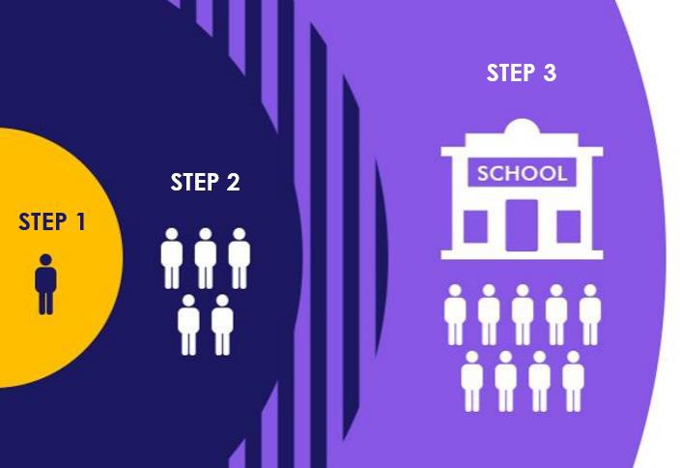

STEP 1 – Safety of those directly involved.
We understand that bullying can have a long-lasting impact on the mental health of all involved, including those who are being bullied, witnessing bullying, and engaging in bullying behaviour. That is why our first step in addressing any instance of bullying is to prioritize the safety and well-being of all individuals involved. We will ask questions such as:

- Are the individuals involved in immediate danger?
- What support and resources do they need to feel safe and secure?
- How can we involve them in the process to ensure their needs and preferences are considered?
It is important to have a record of these considerations, and in most cases, outside agencies such as social workers or the police will not be needed. However, this should always be considered, as the safety of our students and staff is of the utmost importance. We will involve the young people in the process, by asking them what they would like to happen.
STEP 2 – Preventing the bullying from reoccurring.

Once the safety and well-being of those involved in a bullying incident have been secured, the next step is to work with the group of individuals involved to prevent the bullying from reoccurring. As bullying often occurs within a group dynamic, it is important to consider the wider peer group at this stage.

At Bottisham Village College, we use Christina Salmivalli's Role Participant Scale to identify the group and work with those involved. This scale helps us understand the different roles that individuals play in a bullying situation, such as the bully, the victim, and the bystander. More information about these roles can be found in Appendix A.

At this step, we will work through activities to develop a peer strategy that addresses the underlying issues that contribute to bullying. It is important to document the actions taken, involve the students, and keep the actions under regular review.

- Record names of individuals involved in bullying, their roles, and how they were involved. Use My Concern system for recording and following up on incidents.
- Clearly communicate the steps being taken with those involved in the bullying.
- Develop a strategy in collaboration with the target of bullying to address the issue and ensure they are satisfied with the plan.
- Follow the school’s Behaviour Policy, ensuring students that have violated the code of conduct are held accountable and receive appropriate sanctions and consequences. (See section )
- Seek agreement from all parties involved and document this agreement.
- Regularly check in with the target to ensure their well-being and provide a discreet means for them to report any further issues.

- Keep parents/carers informed of actions taken to address the bullying and the impact of those actions.
- Aim to change the behaviour of the group, not just the targeted individual or perpetrator.
STEP 3 – School learning and reflection
Reflecting on our school practice after an incident of bullying or harassment has occurred is crucial in identifying areas for improvement and preventing similar situations in the future.

Steps 2 and 3, which involve addressing the issue and implementing a plan to prevent future occurrences, should be done concurrently with step 1, learning and reflection. It is important not to wait until the issue is resolved before reflecting on our school practices and making necessary changes.

Reflecting on our practice allows us to be proactive and take steps to prevent future incidents of bullying and harassment in our school.

- Reflect on the incident of bullying or harassment and consider the following questions:
  - What has this incident taught us?
  - Does this reveal any issues in the school, such as lack of supervision in certain areas?
  - Do staff need any additional training?
  - Is it necessary to refresh the school's policy and procedures?
  - Is it necessary to revisit the curriculum and ensure students have a better understanding of key areas related to anti-bullying?
  - Do parents have a good understanding of what constitutes bullying and the school's approach to preventing it?
- Identify the steps necessary to make changes and who needs to be involved in implementing them.
- Act on the insights gained from the reflection process to improve the school's approach to preventing and addressing bullying and harassment.
- Continuously monitor and review the effectiveness of these changes to ensure they are working towards the goal of creating a safer and more inclusive school environment for all students.

Timeliness and Quality Assurance
At Bottisham Village College, we are committed to responding to all reports of bullying in a timely, consistent, and effective manner. Clear expectations for time frames and oversight are in place to ensure that all incidents are addressed appropriately and that victims are fully supported.
Response Time Frames
- All bullying concerns must be reviewed and investigated within three school days of being reported.
- Within this period, appropriate initial support for the target must also be put in place, including:
  - A named pastoral contact
  - A calm space or check-in arrangement if required
  - Communication with the student and parents/carers
- The response must be recorded on MyConcern, clearly outlining:
  - The nature of the concern and whether it meets the definition of bullying
  - Actions taken to safeguard the student
  - Planned next steps to prevent recurrence
Ongoing Quality Assurance (QA)
To ensure that incidents are consistently categorised and followed up with rigour, the following Quality Assurance process will be implemented:
- A senior member of staff (DSL or Deputy Principal) will conduct a formal QA review of all bullying concerns every half term.
- The QA process will review:
  - Correct categorisation of incidents (bullying vs. conflict or one-off behaviour)
  - Whether victims have received timely support and communication
  - Evidence that appropriate sanctions, education, and/or restorative actions have been applied to those displaying bullying behaviour
  - Any gaps in follow-up or communication with families
- Patterns and trends will be identified, including:
  - Repeat victims
  - Repeat perpetrators
  - Emerging hot spots or contextual safeguarding concerns
- The outcomes of the QA process will inform:
  - Further staff training
  - Curriculum development (e.g. PSHE focus areas)
  - Additional pastoral interventions for individuals or groups
  - Reporting to the senior leadership team and governing body
This approach ensures that Bottisham Village College maintains high standards of accountability and continuous improvement in tackling bullying, securing a safe and inclusive learning environment for all.

Appendix A - Bullying as a group behaviour.
Research undertaken in Finland by Christina Salmivalli (1996) gave us a greater understanding of the roles involved in bullying. It showed that the traditional view of bullying where there is a ‘victim’ and a ‘bully’ was much more complicated. It can be much more impactful, to understand the group dynamic, trying to impact on all members of the group. The below form can be used as a tool, for bullying incidents that involve a wider group.

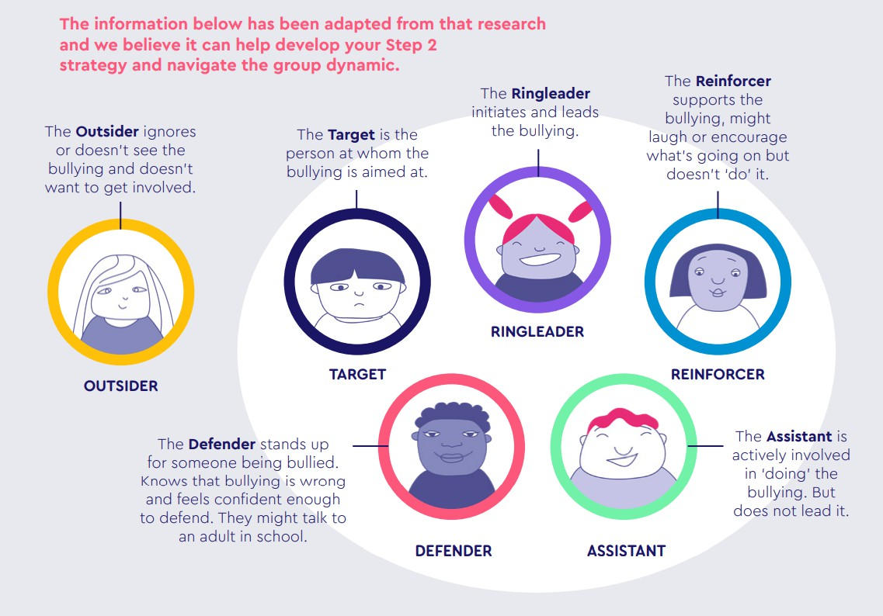
Source: United Against Bullying, Anti Bullying Alliance

Role | Name | How were | What could | Agreement: | Review
 |  | they | this group | What | Review:
 |  | involved? | do to help | approach | What
 |  |  | stop the | have you | levers
 |  |  | bullying? | agreed | did you
 |  |  | (Stop the | to take with | use,
 |  |  | reinforcers | each group? | and did
 |  |  | laughing |  | they
 |  |  | or create |  | work?
 |  |  | defenders)
Target/s
Ring Leader/s
Re-enforcer/s
Assistant/s
Defender/s
Outsider/s

(you don’t need to outline everyone! Just those that you think could potentially have a
positive impact)

Appendix B How Bullying should be recorded
Accurate recording of bullying is important because it allows the school to analyse trends so actions can be taken to support individual students or make changes to how the school operates (for example, how students are supervised). Evidence can also be shared with school governors and Ofsted, to demonstrate the policies and procedures are being followed when Bullying is reported. Bottisham Village College will use the Safeguarding System MyConcern for recording bullying. The reasons we ask for bullying to be reported is as follows:
- It helps to safeguard children and young people
- It provides schools with a record of responses to bullying incidents to support if the school is challenged
- If incidents become a safeguarding issue, it provides vital information
- It can help to highlight if a child needs additional support (target or perpetrator)
- It helps when providing evidence to Ofsted and governors

What to include in a bullying concern log:
  - Name of target(s). You may also want to record details about the demographic of the target here to allow you to identify any groups which may be more vulnerable e.g. SEN status / race / faith etc

What happened?
    - What type of bullying
    - Who was involved? (Use group descriptors, Appendix A)
    - Where did it happen? (On report form, Use MyConcern Locations)
    - When did it happen? (On report form)
  - Was the bullying targeting any aspect of the child’s character? E.g. disability, SEN, looked after, young
carer, LGBT+, race or faith, appearance, gender/sexism. If there is evidence of this happening, this should be clearly recorded in the chronology
  - How was the target (bullied child) affected at the time? - How did the child feel? - What did they think should happen to make it right? - Were there any injuries (use ‘Add Body Map)

Does this constitute a safeguarding issue (child-on-child abuse)? Do you need to record an injury?

  - Who was spoken to and what actions were agreed?
    - Detail actions to address bullying, including education, consequences, restorative discussions, and contracts/agreements.
    - Details of support that has been put in place for students involved.

Did you access any external support?
  - Have parents/carers been updated on how the bullying incident has been managed?
  - Review – has the bullying stopped? How do we know? Have we checked in with the target of the bullying to check it stopped.
